Dylan Hutchison

Calendar Rotation Strategy Backtesting

# Introduction & Motivation

After reading several articles [1] and mutual fund sources [2] online, I wanted to test the strength of a long-term investment strategy that holds stock during the winter months (October – March) and bonds during the summer months (May – September). The idea is that over the long run, stocks perform better during the summer months and tend to lag during the winter month. Here are two figures from [1] that illustrate this trend (note: created in January 2011).

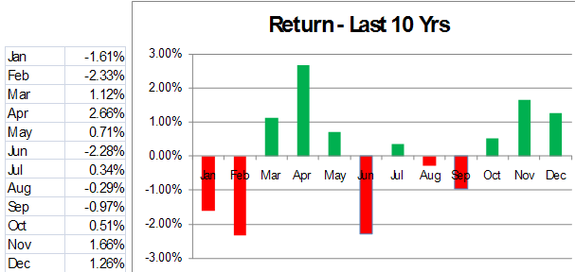

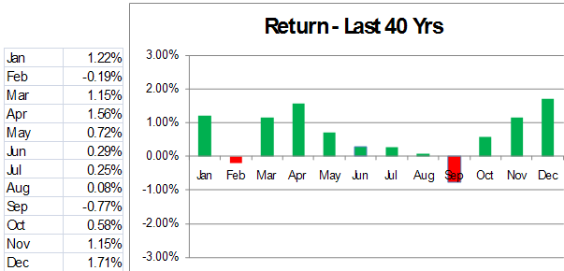

In making the actual investments, I propose the use of ETFs over simple index funds. ETFs provide easy access to diversification within asset classes (equities or fixed income) at very low expense ratios. I would rather take the low expense ratios of ETFs over the “expert active management” of mutual funds, but that is a subject for another debate. When I go to make actual investments, I will favor mid-cap domestic equities and shorter term fixed income assets but make sure to include exposure to other areas such as international equities, corporate bonds, etc. too.

[1] <http://squirrelers.com/2011/01/31/2126/>

[2] <http://time-price-research-astrofin.blogspot.com/2012/03/alphas-mid-cap-power-index-strategy.html>

# Backtesting MDY & SHY

Note: all simulations performed in Matlab using original code

Data: courtesy of [Yahoo Finance](http://finance.yahoo.com/q/hp?s=SPY&a=00&b=1&c=2003&d=11&e=31&f=2012&g=d) for prices and [NASDAQ](http://www.nasdaq.com/symbol/spy/dividend-history#.URw84KU4uRo) for dividend yields and dates

To test this strategy from 2003 to 2012, let’s analyze the growth of $10,000 over the period and calculate the annualized return. Here are my asset choices for testing (keep in mind these are arbitrary—we can re-run the simulation using different data):

1. Equity ETF: SPDR S&P MidCap 400 (MDY)
2. Fixed Income ETF: iShares Barclays 1-3 Year Treasury Bond (SHY)

Before presenting results, here is the performance of the MDY and SHY over the same periods:

Annualized Return = . (P = Stock Price)

MDY: Annual Return over the period of 5/1/2003 – 12/31/2012 is about 16%

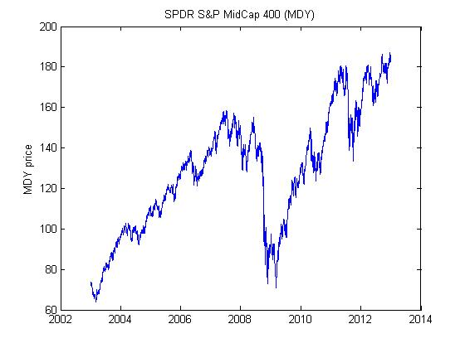

SHY: Annual Return over the period of 5/1/2003 – 12/31/2012 is about 5%

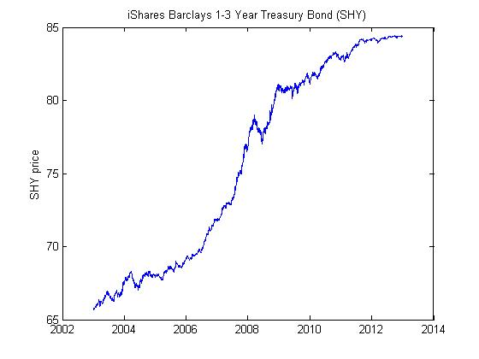

(SHY doesn’t gain in value much, but it’s pretty much constantly increasing)

Now, here is the growth of $10,000 using the calendar rotation strategy, assuming all dividends are reinvested. It delivers a 26% return.

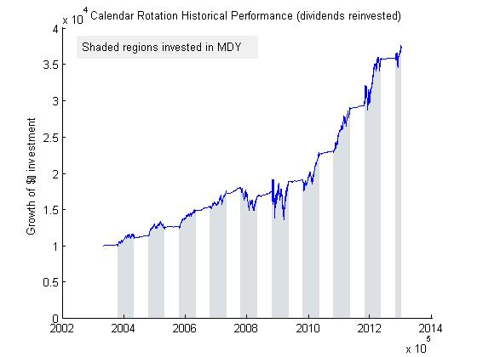

Here is an analysis of the overall return, followed by each equity period and then each fixed income period.

Overall Return (final_val-initial_val)/initial_val: 2.546852

Duration: 3529 days

at EQ->FI date 05/01/03

at FI->EQ date 10/15/03

Annualized = Overall * 365/duration: 0.263418

EQ period: start; end; gain; duration (days); return (annualized)

ret =

Columns 1 through 5

10144 11388 12583 15303 17762

11018 12414 14812 17024 16478

874.2 1026.2 2229.1 1720.6 -1284.3

199 197 196 199 201

0.15807 0.16695 0.32991 0.20622 -0.1313

Columns 6 through 10

17136 18722 22527 28355 34510

18497 21702 28194 34213 35469

1360.7 2980.6 5666.3 5857.7 958.03

198 198 197 199 77

0.14638 0.29349 0.46603 0.37892 0.13159

FI period: start; end; gain; duration (days); return (annualized)

ret =

Columns 1 through 5

10000 11018 12414 14812 17024

10144 11388 12583 15303 17762

143.71 370.33 168.32 491.44 738.34

166 167 168 168 165

0.031599 0.073462 0.029457 0.072085 0.095942

Columns 6 through 10

16478 18497 21702 28194 34213

17136 18722 22527 28355 34510

658.33 224.7 825.14 161.17 297.95

167 167 167 168 165

0.087321 0.026551 0.0831 0.01242 0.019265

As you can see, returns during the equity period vary, but they are all positive except for the 2008 period. Returns from the fixed income period are consistently positive and low.

In order to ensure I chose the best times to sell all fixed income and buy all equities in the Fall and vice versa in the Spring, I varied the transition dates by weeks at a time and found that the optimal times yield:

Max Return of 0.263418

at EQ->FI date 05/01

at FI->EQ date 10/15

Note that the return is not drastically affected by the transition dates. The following graph shows the effect of varying the transition dates on the return:

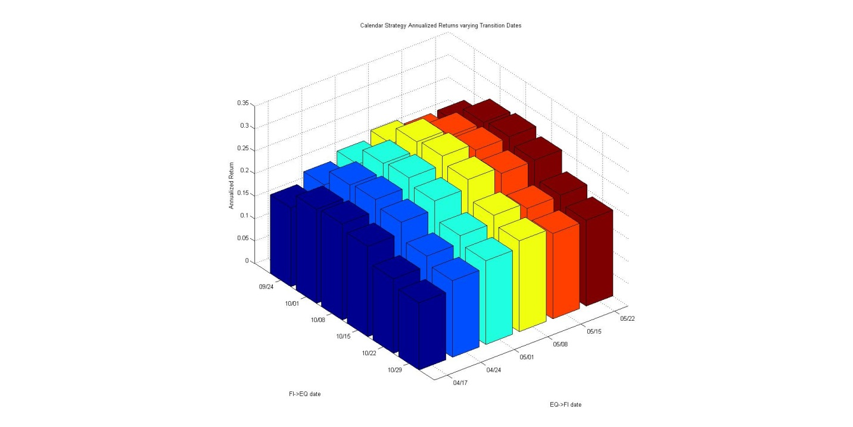

# Backtesting SPY & SHY

A friend recommended I test the strategy on the SPDR S&P 500 (SPY) ETF, a more popular ETF that closely tracks the S&P 500. I repeated the same procedure as with MDY. First, the return to compare against for SPY is **9%** (the result of investing totally in SPY over the timeframe). Here is a graph showing the growth of $10,000 following the calendar rotation strategy, using May 1 and October 15 as the transition dates (again, reinvest all dividends):

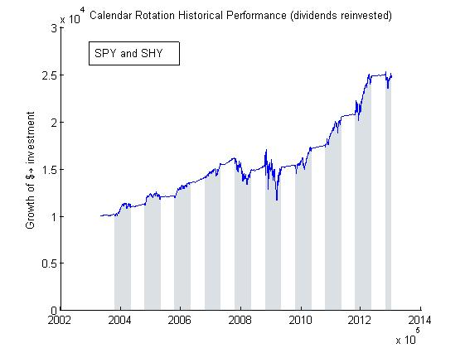

>> CalBackScript_SPY

Overall Return (final_val-initial_val)/initial_val: 1.450985

Duration: 3529 days

at EQ->FI date 05/01/03

at FI->EQ date 10/15/03

Annualized = Overall * 365/duration: 0.150074

EQ period: start; end; gain; duration (days); return (annualized)

ret =

Columns 1 through 5

10144 11254 12075 14009 16071

10904 11937 13590 15403 14558

759.92 683.3 1514.3 1393.9 -1513.2

199 197 196 199 201

0.13741 0.1125 0.23353 0.1825 -0.17098

Columns 6 through 10

15238 15355 17420 20715 24869

15074 16849 20485 24630 24510

-164.32 1493.9 3065.3 3915.3 -358.77

198 198 197 199 77

-0.019878 0.17934 0.32603 0.34667 -0.068386

FI period: start; end; gain; duration (days); return (annualized)

ret =

Columns 1 through 5

10000 10904 11937 13590 15403

10144 11254 12075 14009 16071

143.71 349.92 138.62 419.61 667.73

166 167 168 168 165

0.031599 0.070141 0.02523 0.067084 0.095894

Columns 6 through 10

14558 15074 16849 20485 24630

15238 15355 17420 20715 24869

680.08 281.53 570.73 229.77 238.56

167 167 167 168 165

0.1021 0.040821 0.074035 0.024369 0.021426

Varying the start and end dates, I find the optimal dates are very similar to the MDY and SHY case:

Max Return of 0.152280

at EQ->FI date 05/01

at FI->EQ date 10/22

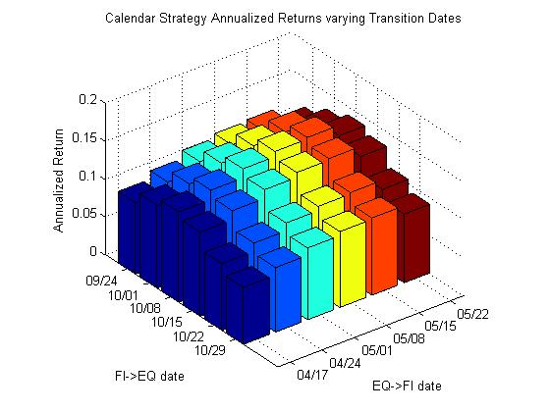

# Conclusion

The calendar rotation strategy looks good. Here are a summary of the returns, compared against the default “invest in all equities all the time” strategy:

|  |  |  |
| --- | --- | --- |
| Fixed Income = SHY | | |
|  | All Equity | Calendar Rotation |
| Equity = MDY | 12.6% | 26.3% |
| Equity = SPY | 9.1% | 15.2% |

The main disadvantage to the strategy is that effectiveness is only plausibly guaranteed in the long run. One must hold to the strategy for many years, even if the first few turn out bad due to bad timing, in order to see it work. Additionally, *past performance does not guarantee future results*, so it is entirely possible this strategy may fail in the future due to a change in culture, trends, market conditions, etc.

Future work might analyze the strategy over different kinds of equities and fixed income assets. For example, would the trend prove stronger if shorter term bonds were used instead of 1-3 year treasury bonds? There are many different possibilities to try.